MEETING AGENDA

Topic:

Thursday, February 20, 2020

10:30-11:30
NAU Biomechatronics Lab (Building 61)

Attendees: (All Team Members)

Please bring:

10:30 | Website check 1 discussion  - Review syllabus  - Identify any remaining tasks and assign  - Potos (Full assembly, manufacturing,
11:00 | Manufacturing update  - Parts/material update  - Status of motor mount design  - Schedule manufacturing time

Implementation Memo
- Review rubric
- Assign tasks that can be started

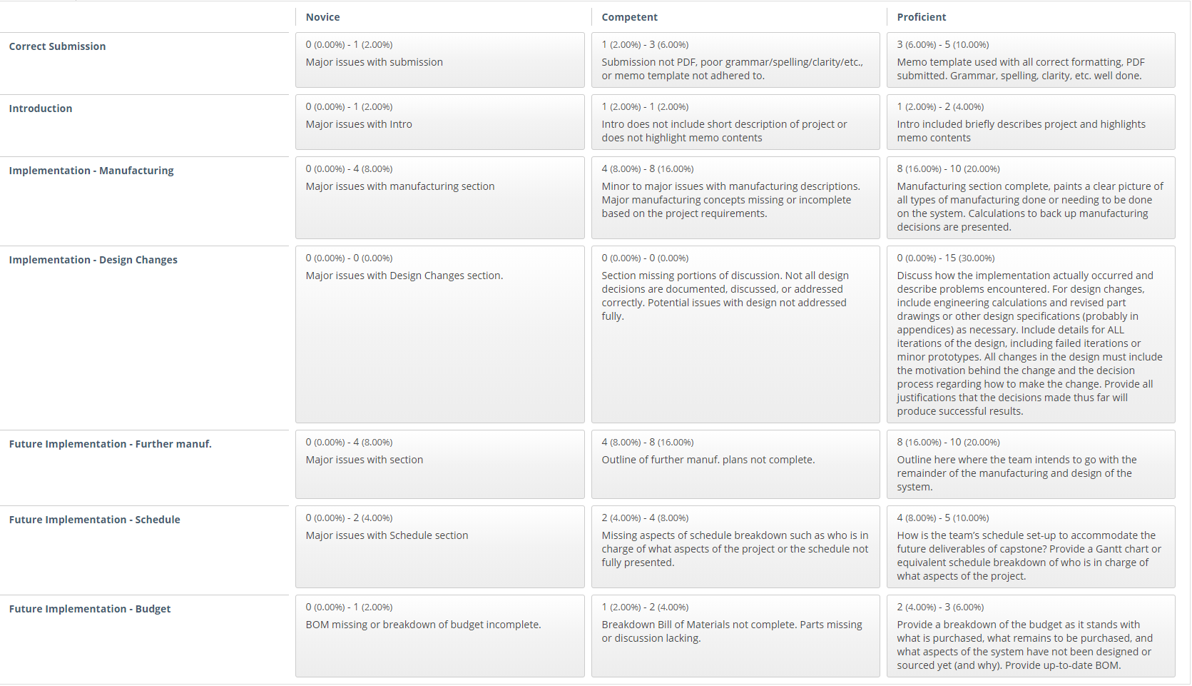
Remaining minutes | Plan for next  - Review assigned tasks  - Ensure task assignments are recorded

